

Dynamics 365  
Technology Specialist Environment



Analytics & Reporting   
Demo Setup – Excel Data

Authored by:

**Scott Sewell**

Principal Program Manager

Fabric BI CAT (Customer Advisory Team)

Version 3.2

Contents

Introduction 2

Getting your Dataverse environment ready 3

*Ensure the Power BI Extensions are updated* 3

*Ensure the option to allow Embedded Power BI content is enabled* 3

Create Local Copies of the Solution and Source Data Excel File 3

Create a OneDrive ‘Shared Library’ 5

Import Solution containing Power BI report and dashboard. 6

Set up Power BI Credentials and Report Refresh 7

Adding the Power BI report to Dynamics 10

Hints 12

# Introduction

These assets are designed to help demonstrate the power of using Power BI analytics and reporting to expose the value of the data in a Dynamics 365 CE implementation. The sample data is sourced from Excel (originally exported from Dynamics) as a way of making them easy to transport from one demo environment to another and to allow for customization for different demo scenarios.

# Getting your Dataverse environment ready

## *Ensure the Power BI Extensions are updated*

In Power Platform Admin Center, under “Dynamics 365 apps”, check to see that the “Power BI Extensions (Preview) application has been updated to at least 1.0.0.77.   
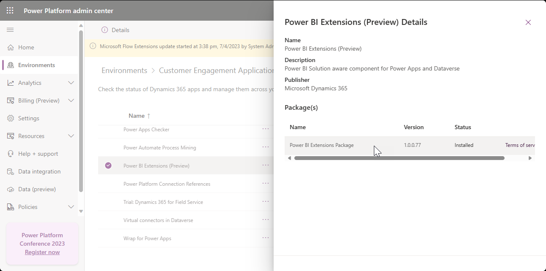

## *Ensure the option to allow Embedded Power BI content is enabled*

In Power Platform Admin Center navigate to “Settings/Product/Features.” Under “Embedded content”, ensure that the “Power BI visualization embedding” option is set to “On.”  
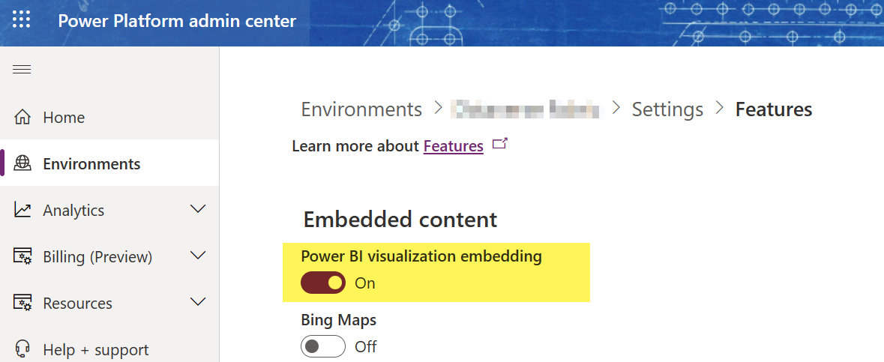

# Create Local Copies of the Solution and Source Data Excel File

1. Download the example files from the source: <https://github.com/mscottsewell/ContosoBI> (From the “Code” menu choose “Download Zip”  
   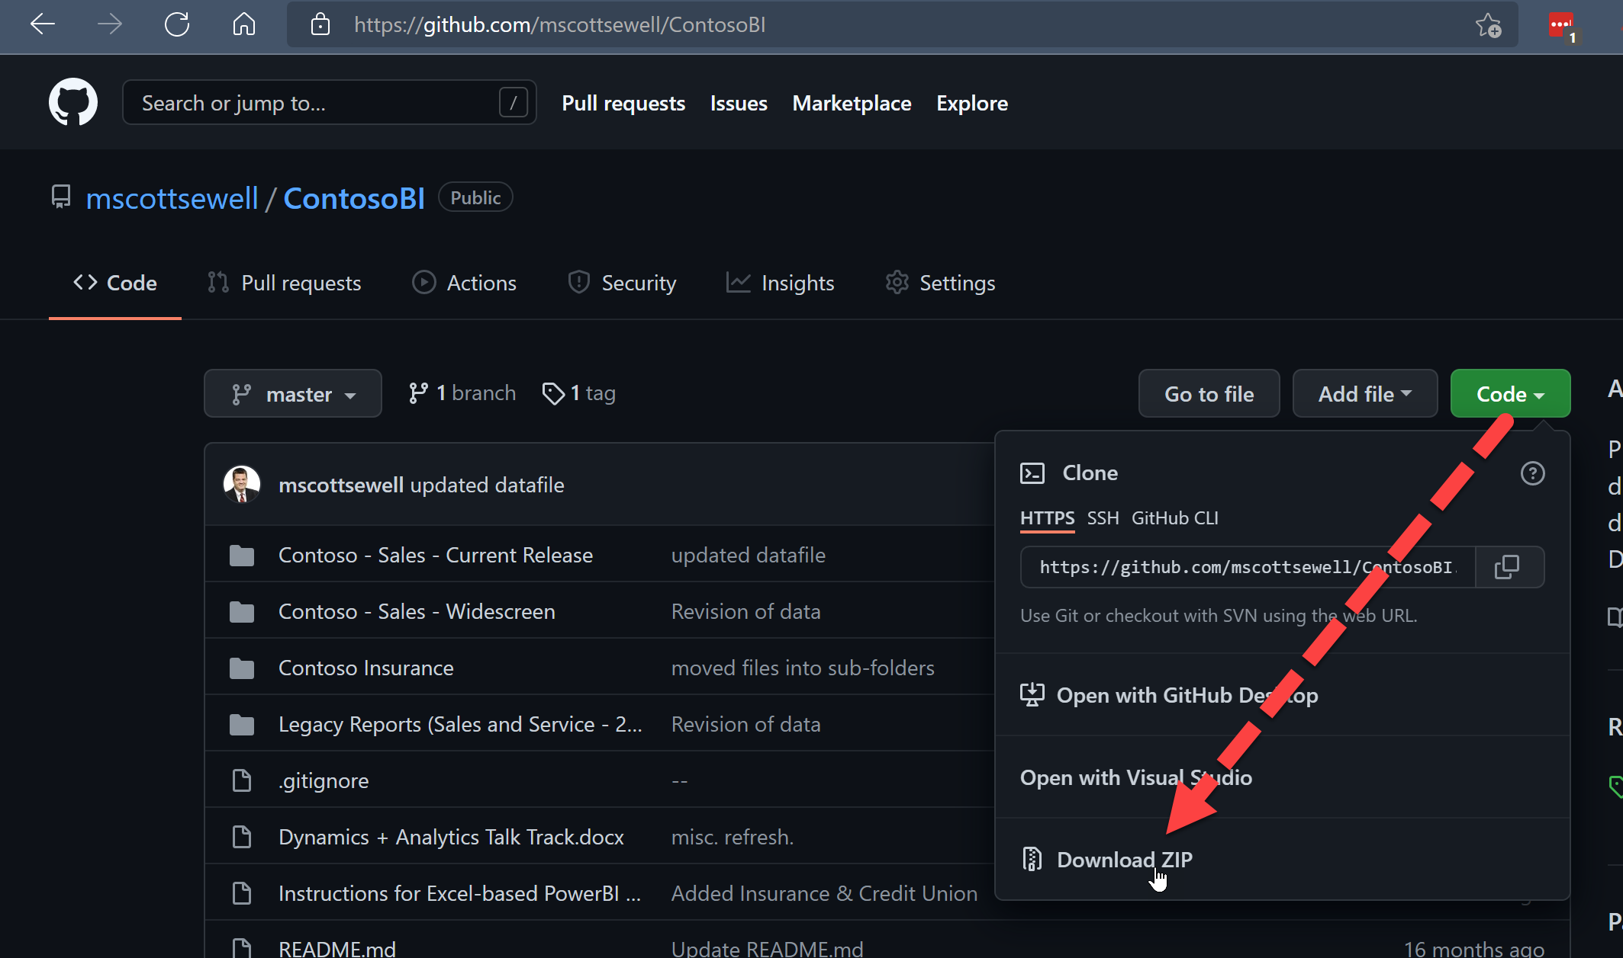
2. Once Downloaded - right click on the file, select ‘Properties’ and then check the ‘unblock’ option and ‘apply’ that change.  
   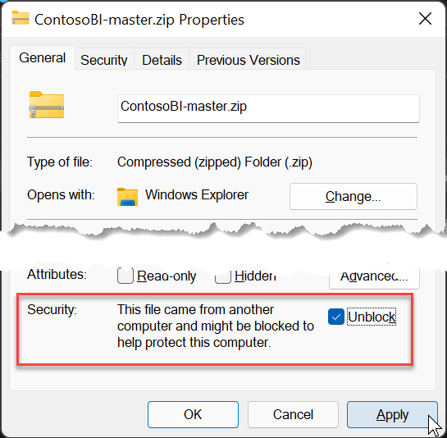
3. Right click on the zip file and “extract” it to a temporary folder on your pc. – We’ll make a few changes before publishing it to your instance.
4. Open “\ContosoBI-master\Contoso - Sales - Current Release\Excel Data”:   
   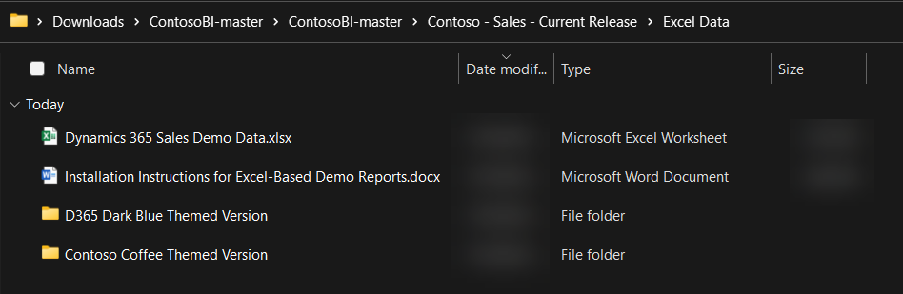

# Create a OneDrive ‘Shared Library’

1. Open OneDrive (logged in with your demo admin credentials)   
   Create a ‘Shared Library’ named “Contoso Analytics”.   
   Add your System Administrator account as a member.  
   Set Privacy to “Public (anyone in the organization)”.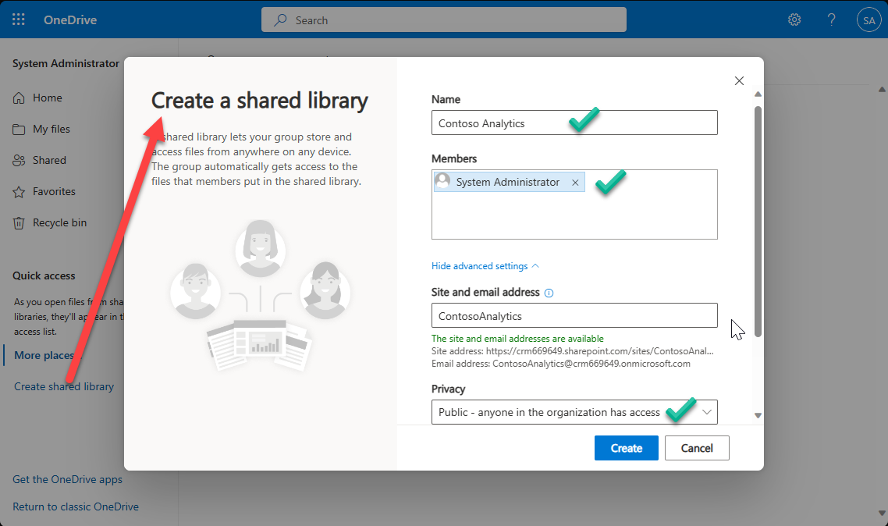
2. Upload the Excel file “Dynamics 365 Sales Demo Data.xlsx” into the new directory.
3. Open the file from One Drive “In App” – (It’s important to open the file *from OneDrive* and not from the copy on your desktop.) – You may be prompted for your demo tenant admin name and password in order to allow Excel to open the file from OneDrive.  
   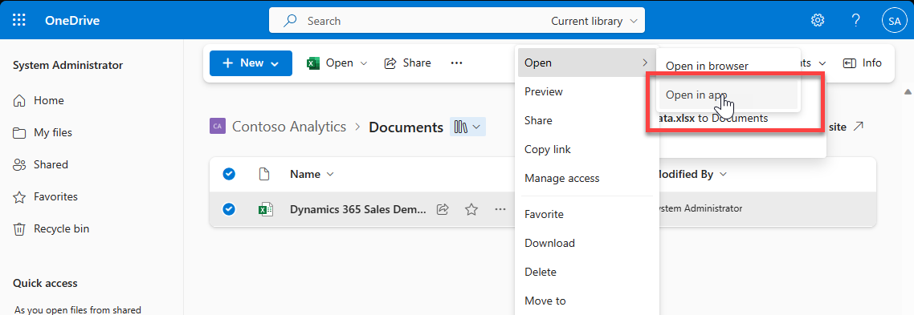
4. With the file open in Excel, click on “File” then “Info” and then “Copy Path” 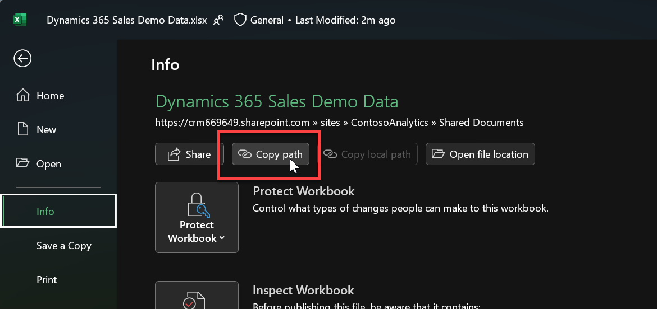

You’ll need this URL in a moment – so just paste it into somewhere handy such as notepad – we’ll use it when importing the solution.

It will look something like:

https://d365demots00000.sharepoint.com/sites/ContosoAnalytics/Shared%20Documents/Dynamics%20365%20Sales%20Source%20Data.xlsx***?web=1***

We’ll need all ***except*** that last **“?web=1”**

https://d365demots00000.sharepoint.com/sites/ContosoAnalytics/Shared%20Documents/Dynamics%20365%20Sales%20Source%20Data.xlsx

# Import Solution containing Power BI report and dashboard.

1. In <https://make.powerapps.com/>, import the **ContosSalesAnalytics_1_0_0_x.zip** solution from the “Contoso Coffee Themed Version” folder. (Alternatively, there is a D365 Dark Blue themed version of the same solution named **D365SalesAnalytics_1_0_0_x.zip** in a separate folder**)**  
   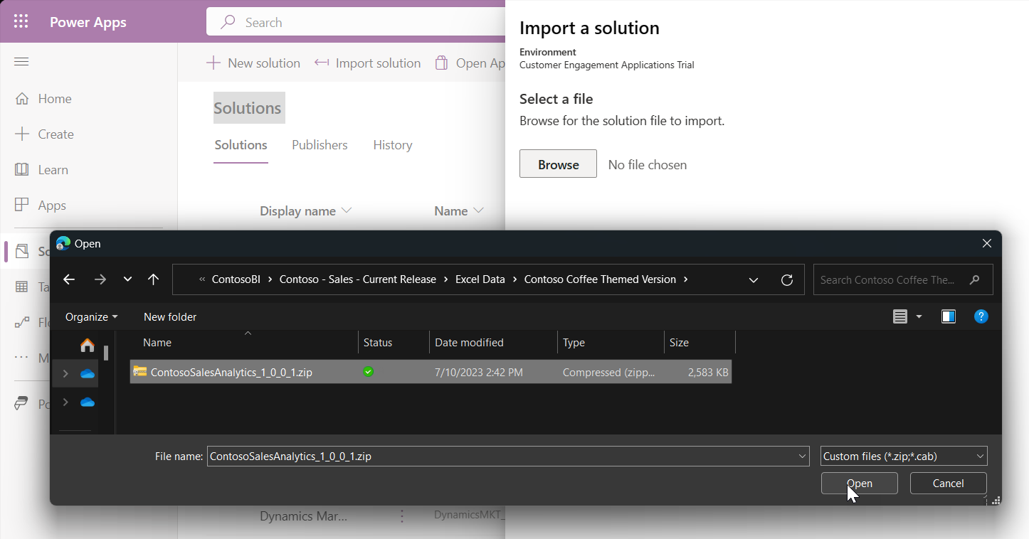
2. During the import you’ll be prompted to enter the **PowerBISampleDataURL** value.  
   Enter the URL you retrieved in the previous section (without the “?web=1”) and press “Import.”  
   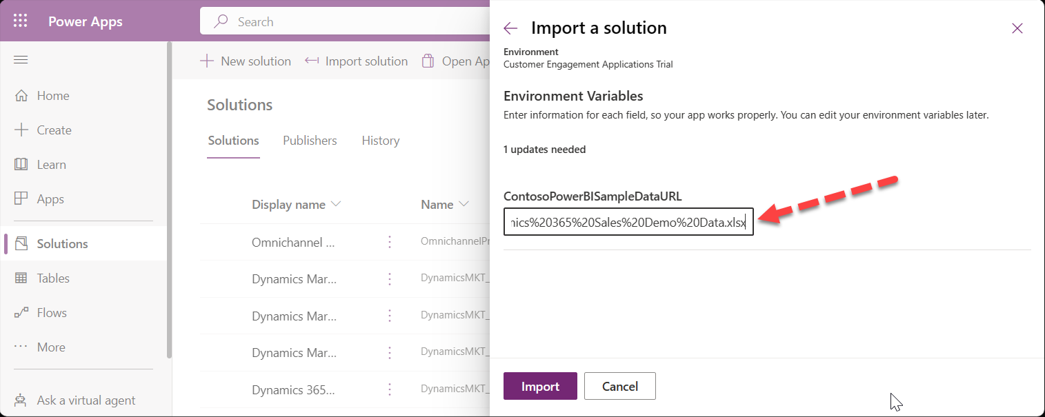
3. Once the import of the solution completes, click Publish All customizations  
   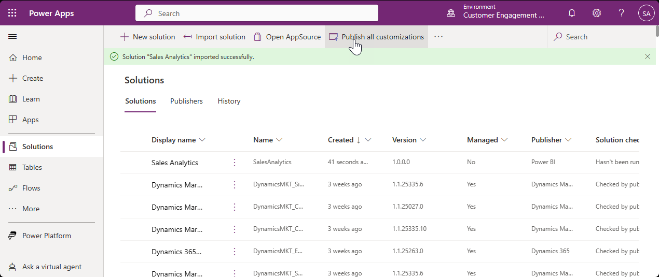

# Set up Power BI Credentials and Report Refresh

1. Open the newly published solution and select the “**Power BI Report**” named “*Dynamics 365 Sales Demo – Excel*” – Then click “Open In Power BI”  
   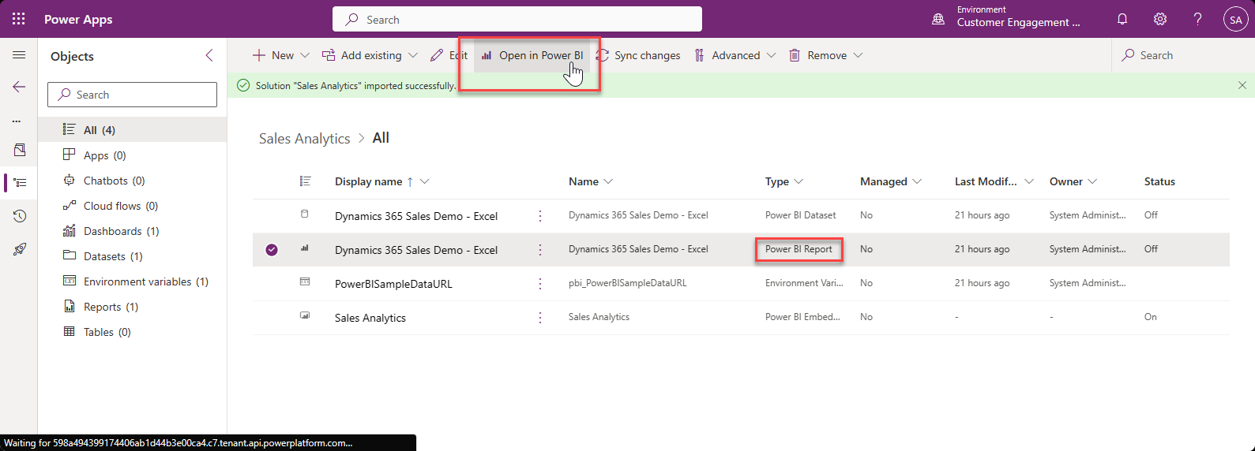
2. Once Power BI opens – select the Workspace (named “Solutions […]” and click the ellipse (“…”) beside the Dataset and open “Settings”.  
   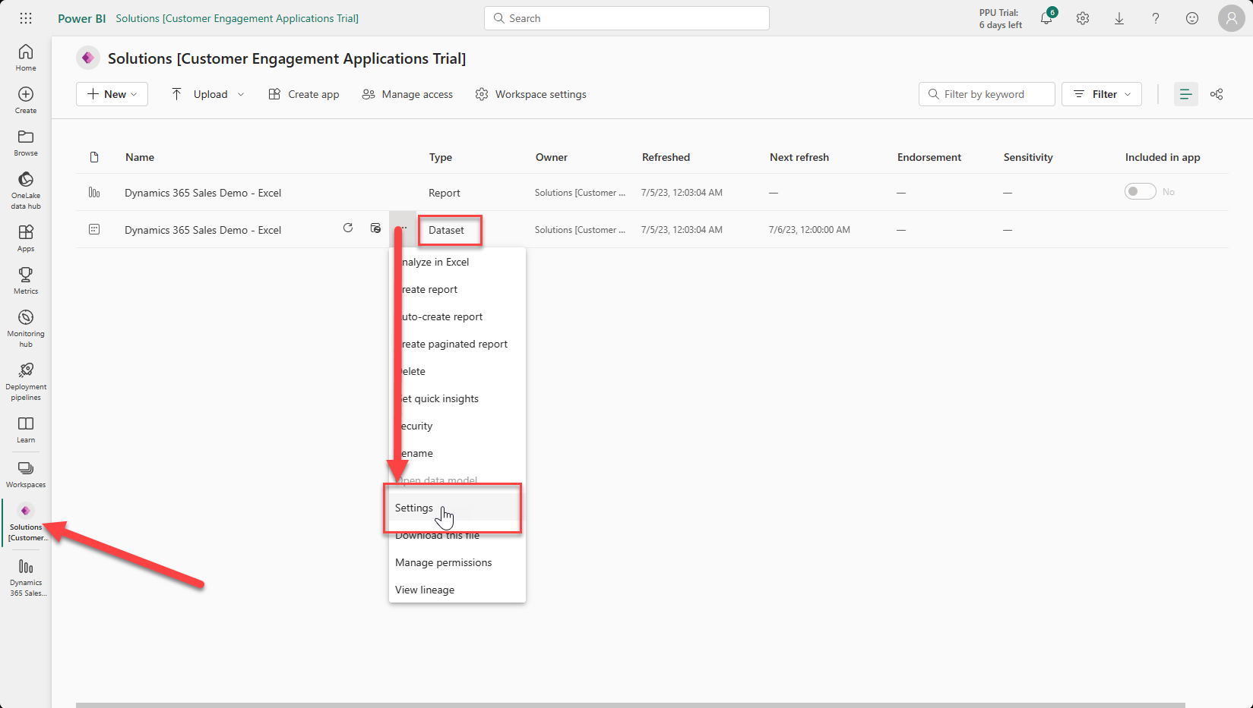
3. You may need to set the “Data source credentials” – if so, just click on ‘Edit Credentials” then select “OAuth2” as the authentication method and enter your demo admin user/password  
   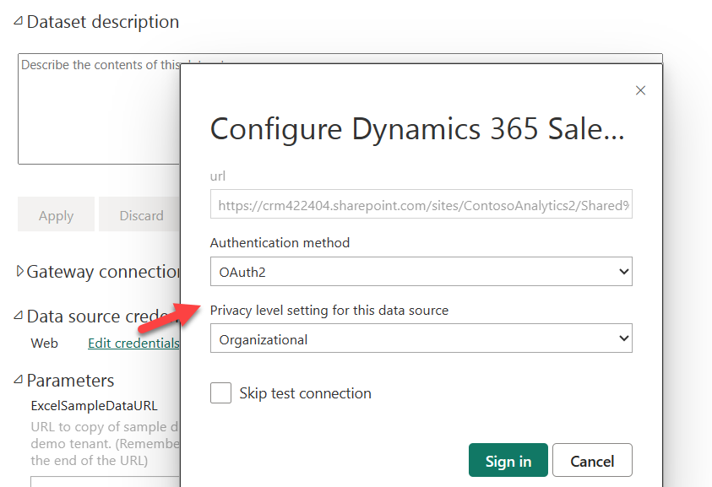
4. Once that’s in place you can scroll a little further down the same list of settings to enable a refresh schedule – (this is done to keep the dates in the report appearing ‘current’)  
   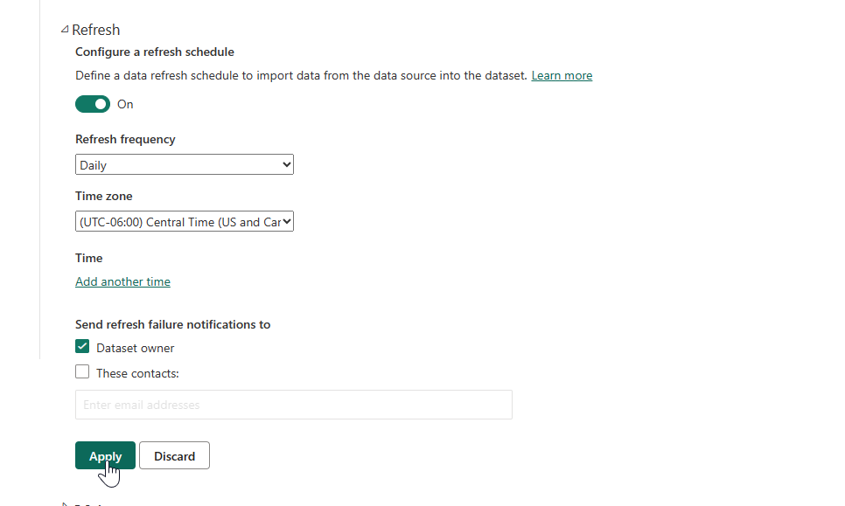  
   (Be sure to click ‘Apply’)
5. If you ever want or need to change which file is used for the report’s data, you can change the URL here in settings under Parameters.  
   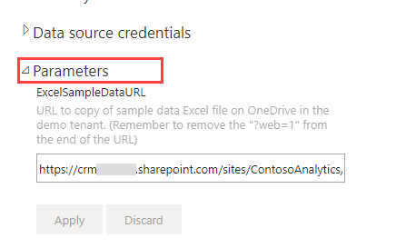
6. Back in the Workspace, beside the Dataset, click on the Refresh icon and ensure the report is refreshed for the first time without errors. -You can open the report from here to verify.  
   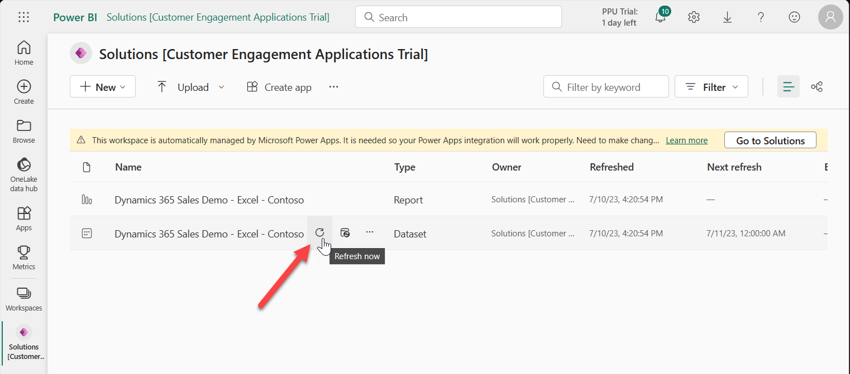

# Adding the Power BI report to Dynamics

1. Open the PowerApp Maker Portal <https://make.powerapps.com/> (be sure your environment is selected) and go to the list of Apps – Select the app you want to add this report to and ‘Edit’  
   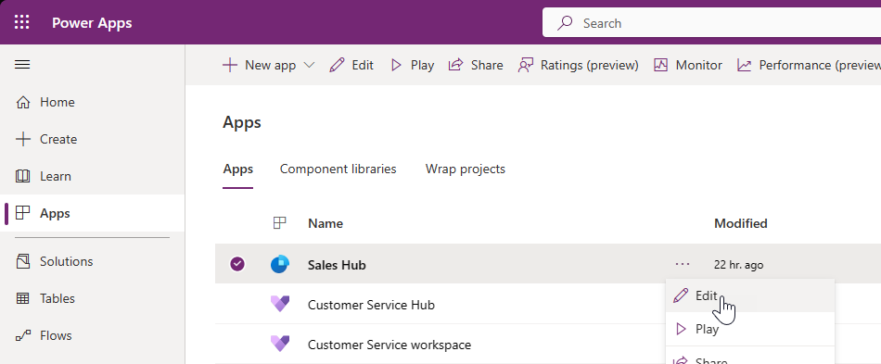
2. Click “Add page” and then select “Dashboard” as the type of page you’re adding.  
   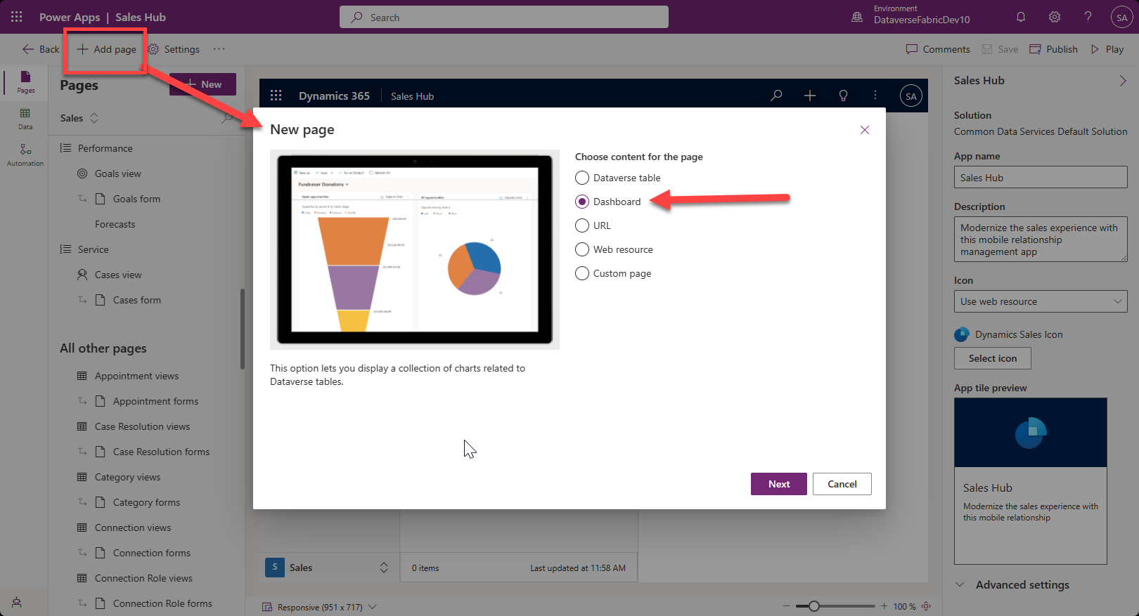
3. Scroll down and choose “Sales Analytics” (or D365 Sales Analytics if you’re using the Dark Blue version.) You’ll find it under Power BI dashboards. Add this report to the list of reports in the “Dashboard” section in the app – Uncheck the ‘Show in navigation’ option.  
   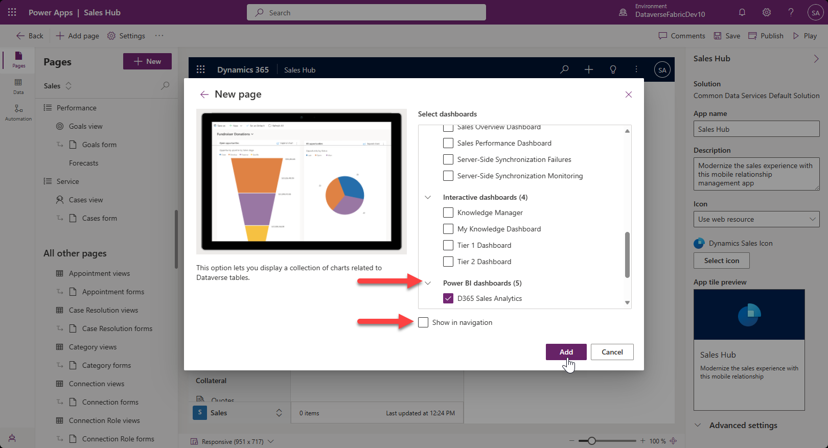
4. Save/Publish/Play to see your new dashboard in the App
   1. Here’s the Contoso Coffee themed version  
      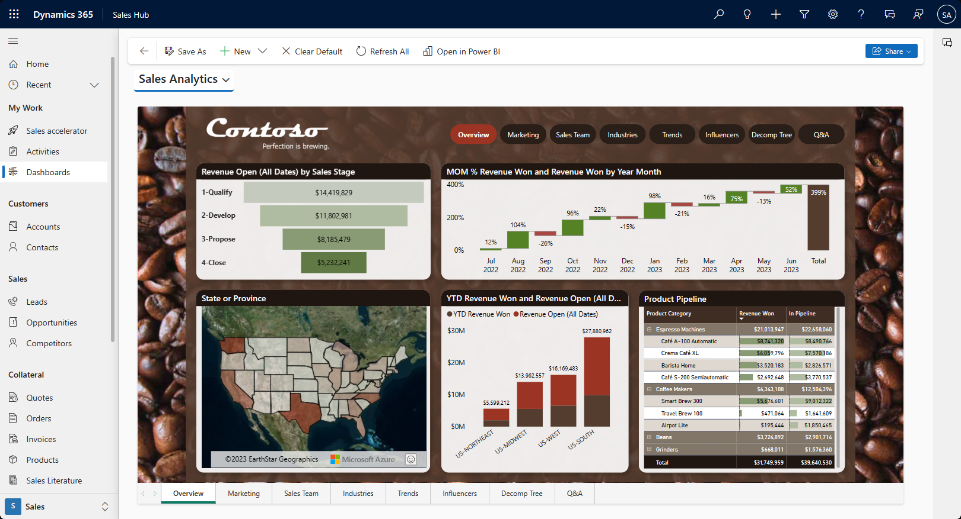
   2. Here’s the D365 Dark Blue themed version  
      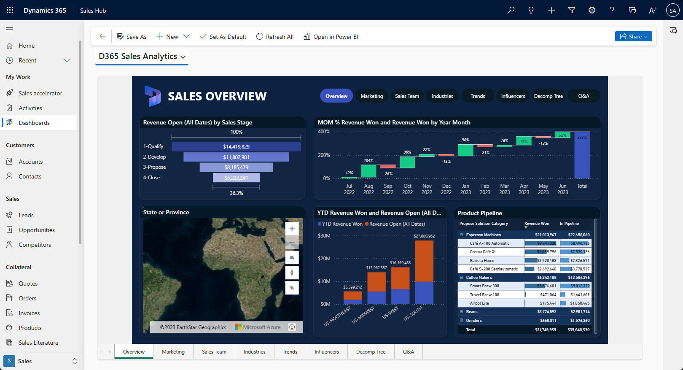

# Hints

1. No more than an hour before a demo it’s a good idea to load the report once and click through everything just to warm up the cache.
2. If the report is open in a tab and sits idle for a period, it may time out – just click the browser’s page refresh button. The ‘Refresh All’ button inside CRM does nothing to reload the report.
3. *Temporary Requirement for enabling Azure Maps*

Power BI is changing to enable Azure Maps by default, but until then, for any new environment you may need to enable the Azure Maps toggle switch. This is a tenant-wide setting, so you only need to set it once per organization.

* 1. In PowerBI.com, click the “Settings” gear icon  
     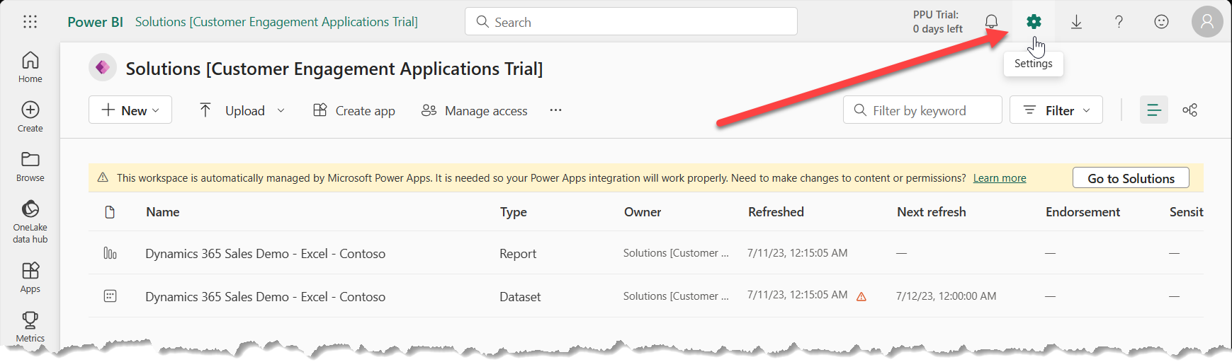
  2. Under “Governance and Insights” Select the “Admin portal”
  3. Scroll down the list of Tenant settings until you find the “Use Azure Maps visual” setting (in the “Integration settings” section.)
  4. Set that value to “Enabled” and click “Apply”  
     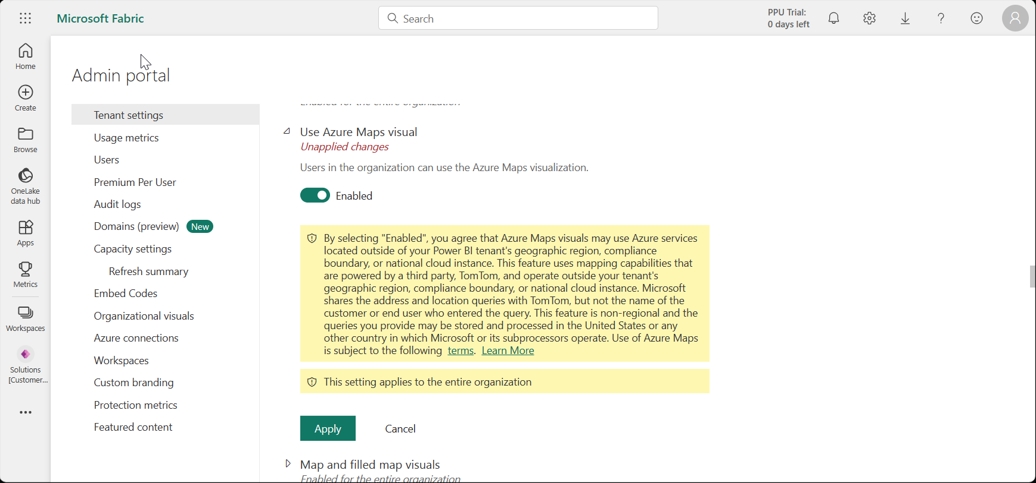
  5. It may take a few minutes for the setting to propagate to your report, but just refresh the page once or twice until the map on the first page displays correctly.